Feature Selection, Model Performance, and Explainability Analysis
1. Introduction
In this study, a machine learning model was developed to predict the likelihood of diabetes using healthcare indicators from the BRFSS 2015 dataset. A Decision Tree classifier was selected due to its simplicity and high interpretability, which aligns well with the goals of Explainable AI (XAI) in healthcare applications.

2. Data Preprocessing and Feature Selection
The dataset was first cleaned by handling missing values using median imputation and removing duplicate records to ensure data quality.
A subset of the most relevant features was selected based on prior feature selection analysis. The final selected features were:
- GenHlth (General Health)
- HighBP (High Blood Pressure)
- BMI (Body Mass Index)
- DiffWalk
- HighChol (High Cholesterol)
- Age
- HeartDiseaseorAttack
- PhysHlth
- MentHlth
- Income
These features represent key health, lifestyle, and demographic factors associated with diabetes risk.

3. Model Performance Analysis
A Decision Tree classifier with controlled depth (max_depth=5) and class balancing (class_weight="balanced") was used.
Results:
- Accuracy: 0.70
- Recall (Diabetes = 1): 0.72
- Precision (Diabetes = 1): 0.29
- F1-score (Diabetes = 1): 0.42

4. Interpretation of Results
4.1 Class Imbalance Effect
The dataset is highly imbalanced:
- Healthy: ~85%
- Diabetic: ~15%
This explains why:
- The model achieves high performance for class 0 (healthy)
- But struggles with precision for class 1 (diabetes)

4.2 Recall vs Precision Trade-off
The model shows:
- High Recall (0.72):
→ Successfully detects most diabetic patients
- Low Precision (0.29):
→ Many false positives (predicts diabetes when it is not present)
This trade-off is expected and acceptable in healthcare, where missing a true patient is more critical than raising false alarms.

4.3 Comparison with Previous Model (Important)
Before applying class balancing, the model had:
- Very low recall (~0.14) for diabetic cases
- High bias toward predicting “healthy”
After applying class_weight="balanced":
- Recall improved significantly to 0.72
- The model became more clinically useful
This demonstrates how handling class imbalance is crucial in medical AI systems.

5. SHAP Explainability Analysis
5.1 Global Feature Importance (Bar Plot)
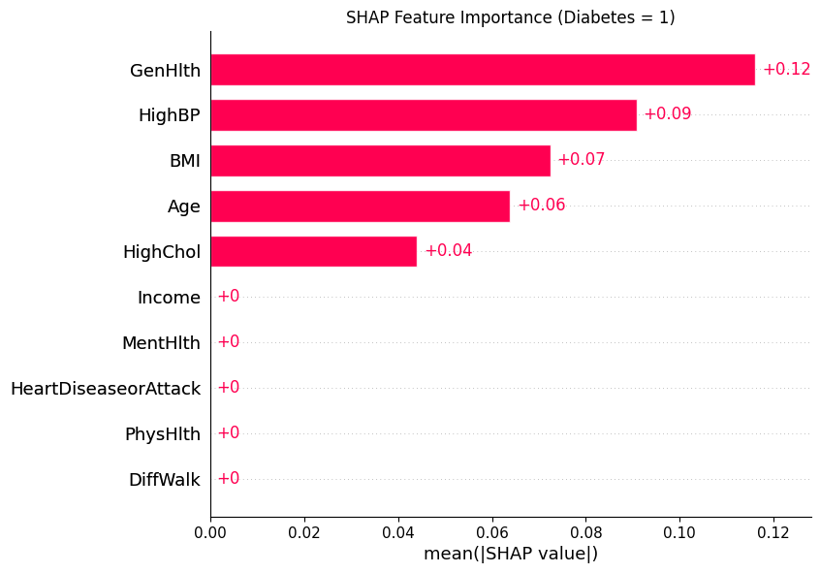

The SHAP bar plot shows the most influential features:
- GenHlth (General Health) → Most important
- HighBP (Blood Pressure)
- BMI
- Age
- HighChol
Interpretation:
- Poor general health strongly increases diabetes risk
- High blood pressure and BMI are major clinical indicators
- Age plays a significant role in disease probability

5.2 Feature Impact (Beeswarm Plot)
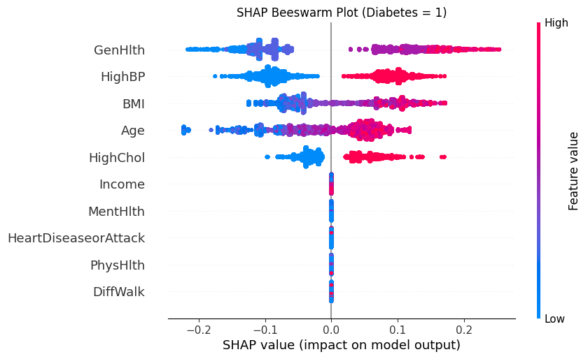

The beeswarm plot provides deeper insight:
- Red points (high values) → push prediction toward diabetes
- Blue points (low values) → push prediction away
Key observations:
- High GenHlth values (worse health) → strongly increase risk
- High BMI → increases diabetes probability
- High Age → positively correlated with diabetes
- High HighBP / HighChol → increase risk
Some features (Income, MentHlth, PhysHlth) have minimal impact, indicating they contribute less to model decisions.

6. Why These Results Occurred
The results are driven by:
Dataset characteristics
- Strong correlation between features like BMI, BP, and diabetes
- Imbalanced class distribution
Model nature (Decision Tree)
- Captures non-linear relationships
- Focuses heavily on top features
- Can oversimplify if depth is limited

7. Does the Model Type Affect Results?
Yes — significantly.
Decision Tree:
- Highly interpretable
- Easy to explain with SHAP
- Lower predictive power
In this project:
- Decision Tree is a good choice for explainability
- But may not be the best for raw performance

8. Conclusion
This study demonstrated the importance of combining machine learning with explainability techniques in healthcare.
Key findings:
- Handling class imbalance dramatically improved model performance
- The model successfully identifies most diabetic cases (high recall)
- SHAP analysis confirmed that general health, BMI, blood pressure, and age are the most critical factors
- There is a clear trade-off between sensitivity and precision
Overall, the model provides interpretable and clinically meaningful insights, making it suitable for decision support systems, despite its limitations in precision.

